

**TRIBHUWAN UNIVERSITY**

**INSTITUTE OF ENGINEERING**

**PASHCHIMANCHAL CAMPUS, POKHARA**

**A PROJECT FINAL REPORT ON**

**An Intelligent Deep Convolutional Neural Network Based Islanding Detection for Multi-DG Systems**

**by**

**Basant Raj Tiwari**

**A FINAL PROJECT REPORT**

**SUBMITTED TO THE DEPARTMENT OF ELECTRICAL ENGINEERING**

**IN PARTIAL FULLFILLMENT OF THE REQUIREMENTS FOR THE**

**DEGREE OF MASTER OF SCIENCE IN ELECTRICAL ENGINEERING IN**

**DISTRIBUTED GENERATION ENGINEERING**

**DEPARTMENT OF ELECTRICAL ENGINEERING**

**PASCHIMANCHAL CAMPUS**

**POKHARA, NEPAL**

**SEPTEMBER, 2024**

**An Intelligent Deep Convolutional Neural Network Based Islanding Detection for Multi-DG Systems**

By

Basant Raj Tiwari

Er. Sushmita Poudel

Supervisor  
Department of Electrical Engineering

Paschimanchal Campus, Tribhuwan University

Submitted to:

**DISTRIBUTED GENERATION ENGINEERING PROGRAM**

**DEPARTMENT OF ELECTRICAL ENGINEERING**

Institute of Engineering, Paschimanchal Campus

Tribhuwan University

Pokhara, Nepal

**ACKNOWLEDGEMENT**

I acknowledge my deep gratitude to my project supervisor Er. Sushmita Poudel and advisor Asst. Prof. Sandeep Dhami for the insightful lessons, guidance and inspiration for the completion of project. These efforts have greatly benefited from their encouragement, suggestions, and observations.

Additionally, I would like to express my gratitude to the Pashchimanchal Campus’s faculty members of the Department of Electrical Engineering for their insightful comments and suggestions during the project's many phases.

I would like to extend my gratefulness to Arif Hussain, Postdoctoral Researcher at Iowa State University for assisting me on the model development of microgrid and giving insights required for the successful completion of the project.

I extend my thanks to my colleagues who provided constant support throughout the study. I take opportunity to thank the authors and publishers of all the sources that helped in every step of this study.

**ABSTARCT**

Unintentional islanding poses a significant challenge in electrical distribution networks, particularly within non-detection zones. This study presents a novel intelligent islanding detection technique with zero non-detection zone, designed for hybrid distributed generation systems. The proposed method combines short-term Fourier transform for frequency spectrum analysis and convolutional neural networks (CNNs) for pattern recognition. The approach involves monitoring three-phase voltage at the point of common coupling and collecting time-series data for various islanding and non-islanding events. These data undergo frequency computations on a scaled time-series, with complex numbers separated into magnitude and phase components. A modified CNN with forward propagation is then employed to distinguish between islanding and non-islanding occurrences.

A test system is modeled that serves as the foundation for generating diverse scenarios to train the CNN. The model's performance is evaluated using 5-fold cross-validation. Results demonstrate that the proposed methodology achieves a zero non-detection zone with the original dataset, exhibiting high accuracy, selectivity, and sensitivity under both normal and noisy conditions.

**TABLE OF CONTENT**

LIST OF FIGURES ……………………………………………………………………………….7

LIST OF TABLES…………………………………………………………………………………8

LIST OF ABBREVIATIONS……………………………………………………………………...9

CHAPTER ONE: INTRODUCTION

1.1) BACKGROUND…………………………………………………………………………...10

1.2) PROBLEM STATEMENT………………………………………………………………...10

1.3) OBJECTIVES………………………………………………………………………………11

1.4) SCOPE AND LIMITATIONS……………………………………………………………..11

1.5) REPORT AND ORGANIZATIONS……………………………………………………….11

CHAPTER TWO: LITERATURE REVIEW…………………………………………………….12

2.1) SHORT-TERM FOURIER TRANSFROM SPECTROGRAM…………………………...12

2.2) CONVOLUTIONAL NEURAL NETWORK……………..…………………………….…13

CHAPTER THREE: METHODOLOGY………………………………………………………..14

3.1) SYSTEM UNDER STUDY…………………………………………………………….….15

3.2) DATA MINING FOR ISLANDING AND NON-ISLANDING SCENARIOS…………...19

3.3) MODELLING AND TRAINING OF CNN………………………………………………...22

CHAPTER FOUR: RESULTS AND DISCUSSIONS…………………………………………...24

4.1) RESULTS OF CNN TRAINING……………………………………………………….…...24

4.2) RESULTS IN TERMS OF VALIDATION ON UNSEEN IMAGES………………………24

CHAPTER FIVE: CONCLUSIONS AND RECOMMENDATION…………………………….27

REFERENCES …………………………………………………………………………………..28

# 

# **LIST OF TABLES**

TABLE 1: DGS AND TRANSFORMER DATA FOR THE TEST SYSTEM 18 TABLE 2: LOAD PARAMETERS FOR THE TEST SYTEM 18

TABLE 3: DATA MINING FOR THE PROPOSED IDT 22

TABLE 4: CNN ARCHITECTURE 23

# **LIST OF FIGURES**

FIGURE 1: SHORT-TERM FOURIER TRANSFORM WORKING 12

FIGURE 2: FLOWCHART OF PROPOSED SCHEME 15

FIGURE 3: TEST SYSTEM FOR THE PROPOSED SCHEME 17

FIGURE 4: SPECTROGRAM OF VOLTAGE SIGNAL AT BUS-4 DURING ISLANDING 20

FIGURE 5: SPECTROGRAM OF VOLTAGE SIGNAL DURING SLG FAULT 20

(NON-ISLANDING) AT DL-1

FIGURE 6: SPECTROGRAM OF VOLTAGE SIGNAL DURING LOAD 21

SWITCHING (NON-ISLANDING) AT ZONE-2

FIGURE 7: OVERALL CONFUSION MATRIX 24

FIGURE 8: CASE 1 25

FIGURE 9: CASE 2 25

FIGURE 10: CASE 3 26

# **LIST OF ABBREVIATIONS**

# 

ANN ARTIFICIAL NEURAL NETWORK

CB CIRCUIT BREAKER

CNN CONVOLUTIONAL NEURAL NETWORK

DFT DISCRETE FOURIER TRASNSFORM

DG DISTRIBUTED GENERATION

FC FULLY CONNECTED

IDT ISLANDING DETECTION TECHNIQUE

NDZ NON-DETECTION ZONE

PCC POINT OF COMMON COUPLING

STFT SHORT-TERM FOURIER TRANSFORM

WT WAVELET TRANSFORM

TTT TIME-TIME TRANSFORM

# **CHAPTER ONE: INTRODUCTION**

# **1.1) Background**

The swift adoption of distributed generation (DG) technologies has garnered considerable attention due to factors like energy market deregulation, investment opportunities, the demand for reliable and high-quality power, and environmental considerations. While traditional power systems rely on centralized generation and transmission, DG integration offers various benefits but also presents challenges. One major concern is unintentional islanding, which occurs when a DG unit continues to operate independently after being disconnected from the main grid [1]. This can lead to safety issues, voltage problems, synchronization difficulties during reconnection, and equipment damage.

To address this, various international and local standards outline criteria for detecting islanding within a specific timeframe. Consequently, researchers have been actively working on developing accurate, reliable, and fast islanding detection methods over the past decade to ensure the secure operation of DG power systems [2].

# **1.2) Problem Statement**

Researchers are continually developing new methods to detect islanding, which is when a part of the power grid becomes unintentionally isolated. These methods fall into three main types: local, remote, and intelligent. Local methods can be further categorized as active, passive, or hybrid.

Active methods work by introducing small disturbances into the system to trigger detection, but these disturbances can sometimes cause problems with noise and power quality. Passive methods, on the other hand, simply monitor the system for natural changes that indicate islanding has occurred. However, these methods may not always detect islanding and can be slow to react. Hybrid methods try to combine the best aspects of both active and passive methods, but they can be more difficult to put into practice and may take longer to detect islanding.

Remote methods rely on communication between the distributed generation unit and the utility company to detect islanding. While these methods are very reliable, they are also complex and expensive, making them unsuitable for smaller power systems.

# **1.3) Objectives**

* To study the efficacy of proposed CNN based IDT for various Islanding scenarios comprising detection around Non-detection and Selectivity against non-islanding scenes.
* To study the Signal Processing Techniques like DFT, STFT and Spectrogram.
* To study how the proposed IDT stands out in contrast to other IDTs.

# **1.4) Scope and Limitations**

This work stands as one of the other alternate islanding detection techniques which is highly accurate, almost has zero NDZ and quick detection time. This work can be used for IDT in PV DG power system applications. The project is more of assessment and verification of application of CNN in detection of islanding detection.  
While the project successfully assesses that indeed CNN based IDT can be used for IDT, but the project has not been tested on real world systems. The real-world systems possess several kinds of noises and other disturbances included in the voltage signal which can change the performance of the trained neural network. The models for DG units and distribution networks may not fully represent the complexity of real-world systems so one has to incorporate these limitations by training the model on the real-world systems.

# **1.5) Report Organization**

The first chapter deals with a brief introduction of the project background, problem statement, objectives, scope and limitation and report organization. In the second chapter, the brief of review of different literature during the study regarding the project is presented. The third chapter provides description of the methodology followed in the course of the study in brief**.** In the fourth chapter, the results obtained are presented and discussed in detail. The fifth chapter presents conclusions of the study and recommendations for the further additions that can be done in the study.

**CHAPTER TWO: LITERATURE REVIEW**

# **2.1) Short-Term Fourier Transform Spectrogram**

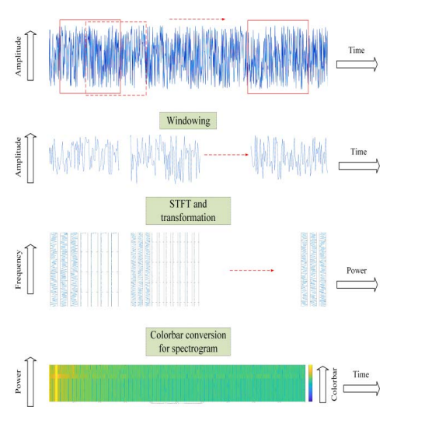Signal processing techniques are crucial for islanding detection, as they can reveal hidden characteristics within measured signals that aid in the detection process. Techniques like STFT, WT, ST, HST, and TTT are particularly useful for improving passive detection methods [3], [4], [5], [6], [7] especially in reducing the non-detection zone (NDZ). While Fourier transforms are commonly used for frequency analysis, they don't capture the temporal distribution of frequencies, making them unsuitable for detecting transient changes. Therefore, Short-Time Fourier Transform (STFT) is employed for time-frequency analysis in this research. STFT breaks down a signal into smaller, potentially stationary segments and analyzes them using a moving window, showing the relationship between time and frequency. This process involves dividing discretely sampled data into chunks, performing Fourier transforms on each chunk to obtain frequency spectra, and then calculating the phase and magnitude for each spectrum. The resulting spectra are visually represented as a spectrogram, where power spectral density is indicated by a color bar, revealing the signal's strength over time and frequency in Figure 1.

Figure 1: Short-Term Fourier Transform Working

The Short-Time Fourier Transform (STFT) is fundamentally a series of discrete Fourier transforms (DFTs) calculated over short segments of a signal, which may or may not overlap. For a discrete-time signal x[n], this can be represented mathematically as in equation (1).

Equation.[1]

Where x[n] is the input signal to be transformed and w[n] is the window function. The squared magnitude of STFT results in a spectrogram representing the power spectral density of the function. According to the uncertainty principle, the time-frequency resolution of the resulting spectrum is determined by the window size used. A bigger size yields higher spectral, but lower temporal, resolution, whereas a smaller size yields the opposite.

# **2.2) Convolutional Neural Network**

The CNN is a well-known deep learning architecture influenced by the automatic visual experience of living beings. CNNs, in contrast, use end-to-end learning, which means that the classifier discovers all the features and then classifies the images, resulting in a data-driven method. A typical CNN model is a combination of a few main layers. The convolutions layer constructs a feature map to predict class probabilities.[11]. The batch normalization (BN) layer standardizes the inputs to a layer to avoid internal covariate shift. After calculating a nonlinear function of the input, a rectified linear unit (ReLU), activates the specific neuron. Pooling layers decrease the amount of information by retaining the most relevant information created by the convolution layer. Fully connected (FC) layers perform the following tasks:

1) The FC input layer can flatten output generated by the previous layer,

2) The FC layers apply weights to simulate precise labels, and

3) The FC output layer produces final probabilities.

Finally, the SoftMax layer measures the class likelihood for the input sample, which is mostly employed in combination with the cross-entropy (CE) loss function. Sets of Equations 2 are the mathematical description of five layers of CNN [10].

Convolutional Layer

Activation or ReLU layer:

Max Pooling (MP) layer:

Fully connected (FC) layer:

SoftMax layer:

Sets of Equations.[2]

CNN calculates the divergence between the real distribution and the distribution created by the model using cross-entropy loss (Y) [9]. Y is computed using Equation.3

Equation.[3]

# **CHAPTER THREE: METHODOLOGY**

The proposed islanding detection technique (IDT) utilizes CNN and STFT for time-frequency analysis, following a four-stage process. First, three-phase voltage data is collected at the point of common coupling (PCC) under various islanding and non-islanding conditions. Second, the three-phase data is combined into a single voltage array. Third, STFT is applied to transform the voltage data into time-frequency representations. Finally, the resulting numeric data, representing phase and magnitude of the frequency spectrum, is fed into a CNN for feature extraction and classification of islanding and non-islanding events. The proposed IDT is based on CNN and STFT computation for time-frequency analysis; the stages of the proposed method are summarized as the flowchart in Figure 3.

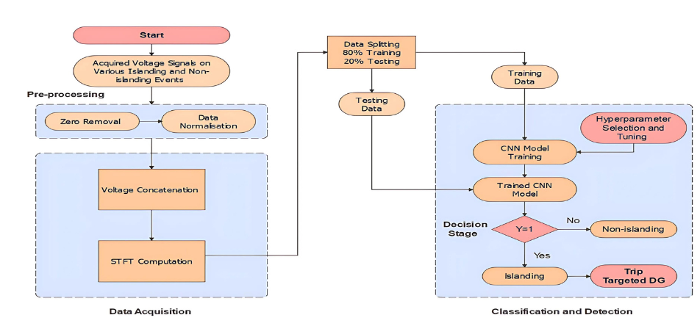

Figure 2: Flowchart of Proposed Scheme [11]

The CNN architecture is optimized for islanding detection with carefully chosen layers, filter sizes, and training hyperparameters to maximize accuracy and efficiency. A three-layer architecture is selected, and the Stochastic Gradient Descent with Momentum (SGDM) optimizer with a learning rate of 0.01 is used. K-fold cross-validation with k=5 is also implemented. In K-fold cross-validation we split the dataset into K equal subsets or "folds". Then we train the model K times, each time using K-1 folds for training and 1-fold for validation. Finally, we average the performance across all K iterations.

The SGDM optimizer estimates the error gradient between the current model output and the desired output, updating the model weights accordingly. The learning rate controls the amount of error used to update the weights, and it's carefully chosen to ensure optimal convergence speed and accuracy.

Also, confusion matrix is evaluated to assess the performance of a classification model. It shows the actual vs. predicted classifications, providing a comprehensive view of the model's accuracy.

**3.1 System Under Study**

The test system consists of several DG units with both synchronous and inverter-based DG as shown in Fig. 4. Zone 1 wraps all DGs and when the CB1 is open the DG system goes into islanded mode when CB1 is open. The zone 2 consists of synchronous based DG only, while zone 3 has two inverter-based DGs and a synchronous DG. A zone 4 has inverter-based DG only and is islanded using CB4. The loads are realized using the RLC loads in Simulink. Various voltage measurements at PCCs have been done and logged to perform the required computation for generating spectrograms. The model was created in MATLAB/Simulink R2021a.

Figure 3: Test System for the Proposed Scheme

Figure 2: Test System for the Proposed Scheme

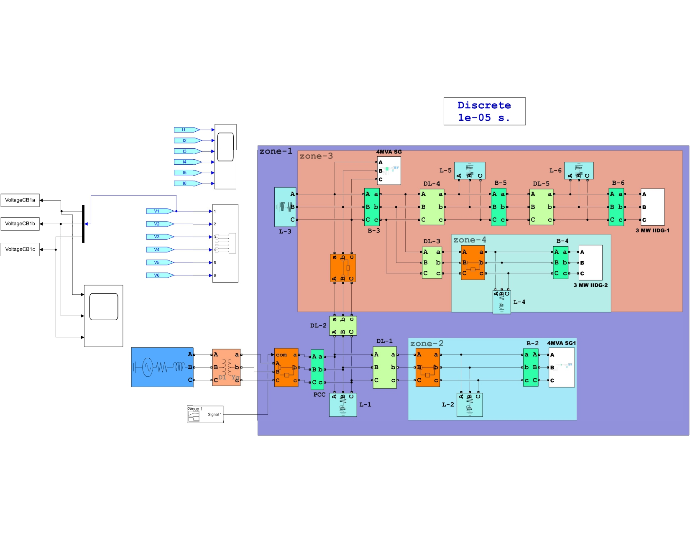

The power and voltage ratings for DGs and transformers used in the test system is tabulated in Table 1.

*Table 1. DGs and transformers data for test system.*

|  |  |  |
| --- | --- | --- |
| DG | Power Rating | Voltage Rating |
| Synchronous based DGs (1&2) | 4 MVA | 2.4kV |
| Inverter based DGs (3 &4) | 3 MVA | 311 V |
| Transformer 1 | 20 MVA | 120/25 kV |
| Transformer 2 &3 | 5 MVA | 2.4/25 kV |
| Transformer 4 & 5 | 5 MVA | 0.311/25 kV |

Note: The choice of particular ratings is based on the main reference paper chosen.

Similarly, the load parameters for the test system are tabulated in Table 2.

*Table 2: Load Parameters for the test System.*

|  |  |  |  |  |  |
| --- | --- | --- | --- | --- | --- |
| Load | P (MW) | Q (MVAR) | Load | P (MW) | Q (MVAR) |
| L1 | 1.5 | 0.6 | L4 | 1.5 | 0.3 |
| L2 | 1.5 | 0.3 | L5 | 0.5 | 0.1 |
| L3 | 1 | 02 | L6 | 1 | 0.3 |

## **3.2 Data Mining for Islanding and Non-Islanding Scenarios**

To mine the data several islanding and non-islanding scenarios need to realize in the test system. The data refers to the voltage data at PCC during the islanding and non-islanding scenarios. For that following procedure will be followed.

1. Obtain the three phase voltage data at PCC during the individual islanding and non-islanding scenario with a simulation time of 0.75s.
2. Export the voltage data back to the MATLAB workspace in the timeseries dataset with a sampling frequency of 3840Hz.
3. Perform STFT for acquired data using the in-built function *spectrogram ()* or we can divide the sampled data into non-overlapping chunks and each chunk is Fourier transformed to obtain the complex frequency spectra.
4. After the STFT computation for each individual scenarios the image data is stored and classified under two categories islanding and non-islanding for training and testing data.

* **Checking the test system and computing the spectrogram.**

The CB at zone-4 is provided an external signal containing the logic level (0) to open at 0.5s so that the zone 4 will be islanded from the system. The three phase voltage data is logged to MATLAB workspace as dataset *“VoltageCB1a”, “VoltageCB1b”, “VoltageCB1c”,* sampled at 3840Hz. The dataset is accessed in the script file as shown in MATLAB code appended in Appendix-I. A MATLAB script is run to produce the spectrogram from the dataset. The spectrogram is shown in Figure 5. Spectrogram’s X-axis and Y-axis indicates the time and frequency respectively.

A SLG fault is introduced at distribution line-1 of zone-1 to realize a non-islanding scenario at 0.5s and the voltage was monitored at PCC. Spectrogram is generated as shown in Figure 6.

# 

Figure 4: Spectrogram of voltage signal at Bus-4 during islanding

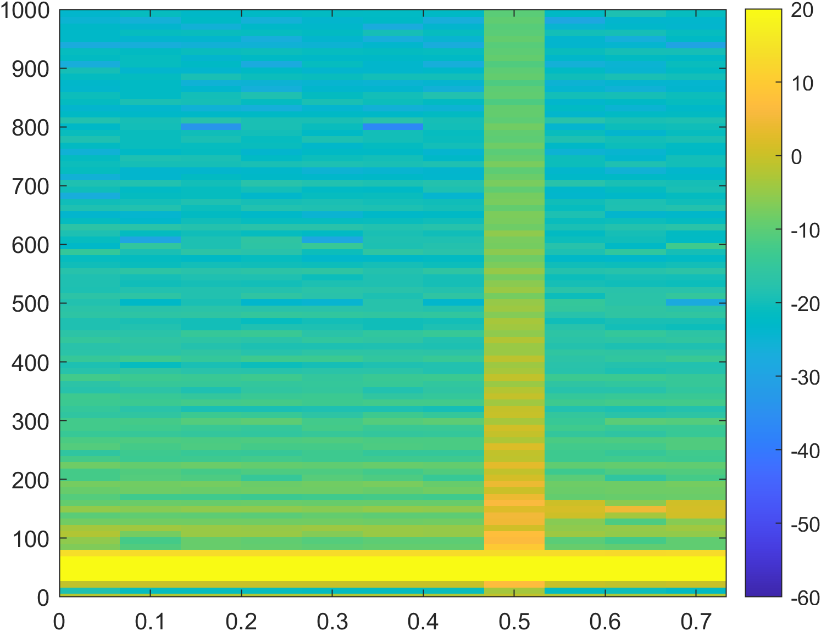

Figure 5: Spectrogram of voltage signal during SLG fault (non-islanding) at DL-1

A case of introduction of a RLC load of 10 MVA at 0.5s is at zone-2 was done to realize a non-islanding based on load switching scenario. The voltage was monitored at PCC and Spectrogram is generated as shown in Figure 7.

# 

Figure 6: Spectrogram of voltage signal during load switching (non-islanding) at zone 2

Similarly, several other scenarios were created for various islanding and non-islanding and spectrogram of each scenario were generated as detailed in table below.

|  |  |
| --- | --- |
| Islanding and non-islanding cases on various disturbances | No. of Cases |
| **Islanding**   * Islanding by changing ∆P and ∆Q from (-50% to +50%) and (-25% to +25%) respectively. * Non detection Zones cases | **1050**  800  250 |
| **Non-islanding**   * Faults on DL-1 and DL-2 (SLG, DLG, TLG) by changing fault resistance from (0.1-100 Ω). * Load Switching on L2, L4, L5 in the range of (0.5-50 MVA), (5-55 MVA), (10-70 MVA). | **1050**  980  70 |
| **Total Islanding and non-islanding cases** | **2100** |

*Table 3: Data Mining for the proposed IDT*

## **3.3 Modelling and Training of CNN**

To create a model of CNN, the CNN architecture presented in Table 4 was used. To realize the architecture in code, MATLAB Deep Learning Toolbox environment was used. The code required is presented in the Appendix -I.

**Training Options:** -

Optimizer: SGDM (Stochastic Gradient Descent with Momentum)

Initial Learn Rate: 0.01

Max Epochs: 10

Mini Batch Size: 32

Shuffle: Every epoch

Validation Frequency: 30

Execution Environment: CPU

Validation Method: k-fold; k=5

*Table 4: CNN Architecture*

|  |  |  |  |  |  |  |
| --- | --- | --- | --- | --- | --- | --- |
| Layer | Type | Output Size | Kernel Size | Filters | Stride | Padding |
| Input | Image Input | 224 x 224 x 3 | - | - | - | - |
| 1 | Convolution 2D | 224 x 224 x 16 | 3 x 3 | 16 | 1 | same |
| 2 | Batch Normalization | 224 x 224 x 16 | - | - | - | - |
| 3 | ReLU | 224 x 224 x 16 | - | - | - | - |
| 4 | Max Pooling 2D | 112 x 112 x 16 | 2 x 2 | - | 2 | - |
| 5 | Convolution 2D | 112 x 112 x 32 | 3 x 3 | 32 | 1 | same |
| 6 | Batch Normalization | 112 x 112 x 32 | - | - | - | - |
| 7 | ReLU | 112 x 112 x 32 | - | - | - | - |
| 8 | Max Pooling 2D | 56 x 56 x 32 | 2 x 2 | - | 2 | - |
| 9 | Convolution 2D | 56 x 56 x 64 | 3 x 3 | 64 | 1 | same |
| 10 | Batch Normalization | 56 x 56 x 64 | - | - | - | - |
| 11 | ReLU | 56 x 56 x 64 | - | - | - | - |
| 12 | Global Average Pooling 2D | 1 x 1 x 64 | - | - | - | - |
| 13 | Fully Connected | 1 x 1 x 2 | - | 2 | - | - |
| 14 | Softmax Layer | 1 x 1 x 2 | - | - | - | - |
| 15 | Classification Output | - | - | - | - | - |

Based on above architecture a CNN model was developed in MATLAB and trained and tested.

# **CHAPTER FOUR: RESULTS AND DISCUSSIONS**

## **4.1 Results of CNN Training**

After the training is completed, the confusion matrix is published as shown in figure below. The confusion matrix represents for all the folds of validation with 2 cases mis-classified. After the training session the mean accuracy was calculated which was 99.9%.

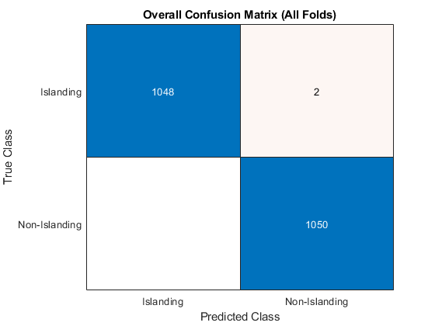

Figure 7: Overall Confusion Matrix

## **4.2 Results in Terms of Validation on Unseen Images**

As the scope of this project didn’t involve on testing the model at real word test-system, some sets of unseen images with islanding and non-islanding at different instances of time were created. Then they were fed to the model to classify those images containing the information of either islanding or non-islanding. The categorical classification results of those images with confidence of prediction are shown below.

Case 1: Islanding created at 0.5s with generation and load being almost similar (a case of NDZ) at the zone of interest.

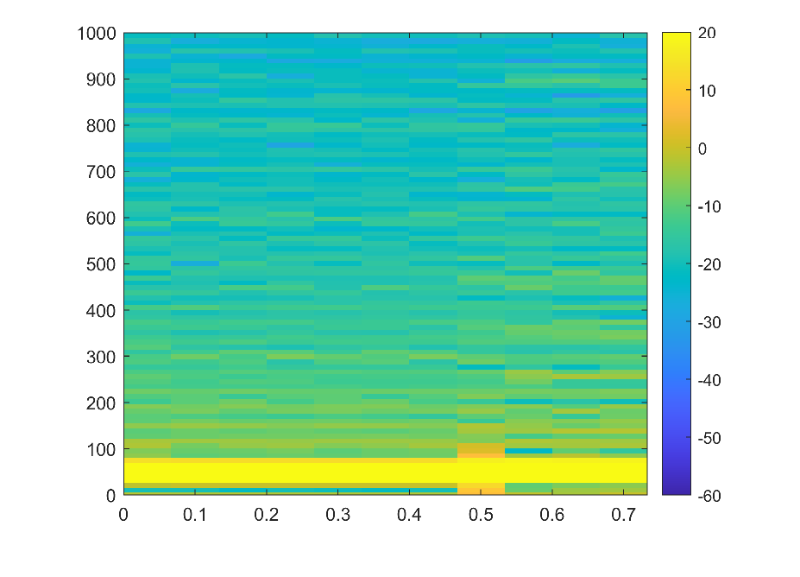

message = "Islanding Condition Detected"

message1 = " The confidence level of classification is 99.9029 %"

Case 2: Non-islanding created at 0.5s.

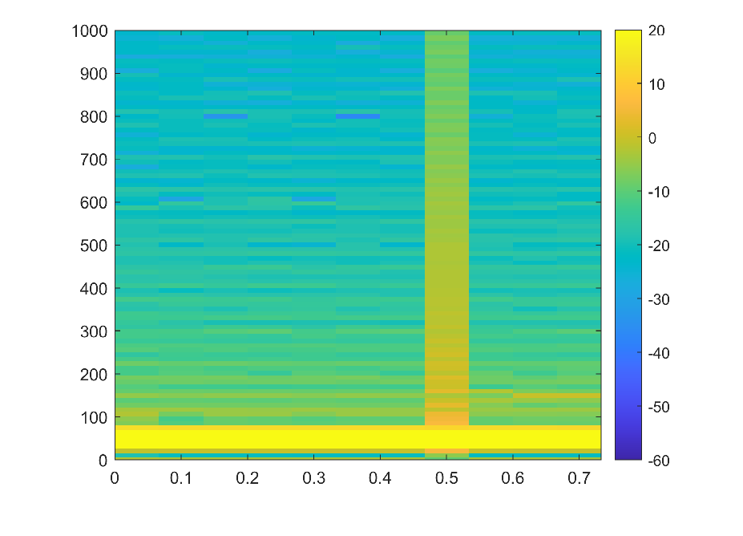

message = " The abnormality in voltage waveform does not correspond to islanding condition"

message1 =" The confidence level of classification is 99.2865 %"

Case 3: Islanding created at 0.3s.

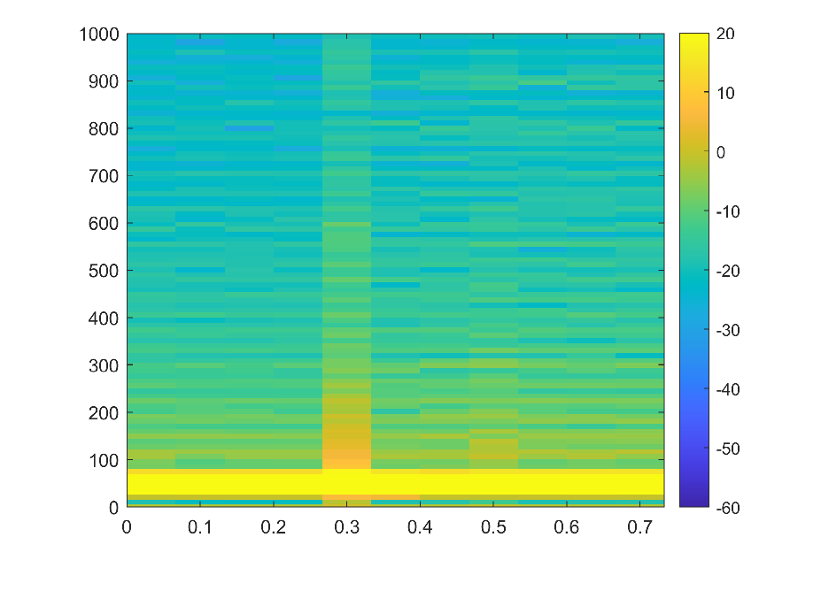

message = " Islanding Condition Detected"

message1 = " The confidence level of classification is 99.5984 %"

**CHAPTER FIVE: CONCLUSION AND RECOMMENDATION**

After completing project, we can conclude that CNN can be used to detect the islanding and non-islanding conditions with great accuracy. While the training and testing of the data led to mean accuracy of 99.9% for categorical classification, validation of unseen images done further assures the confidence of model in predicting the outcomes. So, once we train a model, we can use that model parameters for classifying the voltage signals measured at PCC. The classifier will classify the signal and may send a corresponding signal to controller to make further decisions on opening or avoiding the opening of CBs.

Though the detection time could not be assessed in hands in this project but one can realize it with using the trained model on real world test systems. During the project several realizations were done regarding how to continuously monitor the voltage signal at PCC along with the several noises that might impact the data passed to the model. This can mislead the model and false classification could happen. So, one has to train the model along with noise realization.

**REFERENCES**

[1] A. Khamis, H. Shareef, E. Bizkevelci, and T. Khatib, ‘‘A review of islanding detection techniques for renewable distributed generation systems,’’ Renew. Sustain. Energy Rev., vol. 28, pp. 483–493, Dec. 2013, doi: 10.1016/j.rser.2013.08.025

[2] A. Hussain, C.-H. Kim, and A. Mehdi, ‘‘A comprehensive review of intelligent islanding schemes and feature selection techniques for distributed generation system,’’ IEEE Access, vol. 9, pp. 146603–146624, 2021.

[3] S. R. Mohanty, N. Kishor, P. K. Ray, and J. P. S. Catalo, ‘‘Comparative study of advanced signal processing techniques for islanding detection in a hybrid distributed generation system,’’ IEEE Trans. Sustain. Energy, vol. 6, no. 1, pp. 122–131, Jan. 2015, doi: 10.1109/TSTE.2014.2362797.

[4] C.-T. Hsieh, J.-M. Lin, and S.-J. Huang, ‘‘Enhancement of islandingdetection of distributed generation systems via wavelet transform-based approaches,’’ Int. J. Electr. Power Energy Syst., vol. 30, no. 10, pp. 575–580, Dec. 2008, doi: 10.1016/j.ijepes.2008.08.006.

[5] S. Raza, H. Mokhlis, H. Arof, J. A. Laghari, and L. Wang, ‘‘Application of signal processing techniques for islanding detection of distributed generation in distribution network: A review,’’ Energy Convers. Manage., vol. 96, pp. 613–624, May 2015, doi: 10.1016/j.enconman.2015.03.029.

[6] M. Hanif, M. Basu, and K. Gaughan, ‘‘Development of EN50438 compliant wavelet-based islanding detection technique for three-phase static distributed generation systems,’’ IET Renew. Power Gener., vol. 6, no. 4, p. 289, 2012, doi: 10.1049/iet-rpg.2011.0290.

[7] P. K. Ray, S. R. Mohanty, and N. Kishor, ‘‘Disturbance detection in grid connected distributed generation system using wavelet and S-transform,’’ Electr. Power Syst. Res., vol. 81, no. 3, pp. 805–819, Mar. 2011, doi: 10.1016/j.epsr.2010.11.011.

[8] Y. Sun, B. Wang, J. Jin, and X. Wang, ‘‘Deep convolutional network method for automatic sleep stage classification based on neurophysiological signals,’’ in Proc. 11th Int. Congr. Image Signal Process., Biomed. Eng. Informat. (CISP-BMEI), Oct. 2018, pp. 1–5, doi: 10.1109/CISP-BMEI.2018.8633058.

[9] T. Chakravorti, R. K. Patnaik, and P. K. Dash, ‘‘Detection and classification of islanding and power quality disturbances in microgrid using hybrid signal processing and data mining techniques,’’ IET Signal Process., vol. 12, no. 1, pp. 82–94, Feb. 2018, doi: 10.1049/iet-spr.2016.0352.

[10] S. K. G. Manikonda and D. N. Gaonkar, ‘‘IDM based on image classification with CNN,’’ J. Eng., vol. 2019, no. 10, pp. 7256–7262, Oct. 2019, doi:10.1049/joe.2019.0025.

[11] A. Hussain, C.-H. Kim, and M. S. Jabbar, ‘‘An intelligent deep convolutional neural networks-based islanding detection for multi-DG systems,’’ IEEE Access, vol. 10, pp. 131920–131931, 2022, doi:10.1109/ACCESS.2022.3229698

**APPENDIX -I**

* The MATLAB code referenced in Section 3.2 is written below.

#

clear all;

% This bit of code is for variation in Active/Reactive Power in Zone-1

basw=[];

perc=0.75;

while perc<=1.25

basw(1,end+1)=(((14*perc)^2-49)^0.5)-0.6;

perc=perc+0.008;

end

% % This bit of code is for variation in Active /Reactive Power in Zone-2

perc=0.75;

basw=[];

while perc<=1.25

basw(1,end+1)=((4*perc)^2-2.25)^0.5;

perc=perc+0.01;

end

% % This bit of code is for variation in Active /Reactive Power in Zone-3

perc=0.75;

basw=[];

while perc<=1.25

basw(1,end+1)=((10*perc)^2-16)^0.5;

perc=perc+0.01;

end

% % This bit of code is for variation in Active /Reactive Power in Zone-4

perc=0.75;

basw=[];

while perc<=1.25

basw(1,end+1)=((3*perc)^2-2.25)^0.5;

perc=perc+0.01;

end

%This code segment is for variation in Fault resistance at DL-1

res=[0.1 0.5];

for s=2:200

res(1,end+1)=res(1,s)+0.5;

end

%This code segment is for variation in Fault resistance at DL-2

res=[0.1 0.5];

for s=2:200

res(1,end+1)=res(1,s)+0.5;

end

% This bit of code to realize various load switching scenarios

load1=[5 7];

for s=2:10

load1(1,end+1)=load1(1,s)+2;

end

warning('off', 'all');

for d= 1:length(load1)

bas=basw(d)*1e6

loadsim=load1(d)*1e6

% bas=res(d)

sim('IDTmodel');

Va= VoltageCB1a.Data(1:end);

Vb= VoltageCB1b.Data(1:end);

Vc= VoltageCB1c.Data(1:end);

voltage_data=[Va'; Vb'; Vc'];

% Parameters from the paper

Fs = 3840; % Sampling frequency (Hz)

T = 0.75; % Total simulation time (s)

% Generate time vector

t = 0:1/Fs:T-1/Fs;

% Parameters for STFT

window = hamming(256); % Window function

noverlap = 0; % Number of overlapped samples

nfft = 360; % Number of FFT points

% Compute STFT for each phase and combine

S_phases = zeros(nfft/2+1, floor((length(t)-noverlap)/(length(window)-noverlap)), 3);

for phase = 1:3

[S, F, T] = spectrogram(voltage_data(phase,:), window, noverlap, nfft, Fs, 'yaxis');

S_phases(:,:,phase) = abs(S);

end

S_max = max(S_phases, [], 3); % Method 2: Maximum

% Plot spectrogram

figure;

imagesc(T, F, 20*log10(S_max)); % Convert to dB scale

axis xy; % Put low frequencies at the bottom

% xlabel('Time (s)');

% ylabel('Frequency (Hz)');

ylim([0 1000]);

% title('Combined Three-Phase Voltage Spectrogram');

colorbar;

caxis([-60 20]); % Adjust color scale as needed

% Save the spectrogram image

folderPath = 'C:\Users\Dell\Desktop\Project MSC Third Sem\MATLAB Files\Scripts\Datasets\Islanding';

a=4

fileName= [ num2str(a) '.png']

fullPath = fullfile(folderPath, fileName);

exportgraphics(gcf,fullPath,'Resolution',300);

% end

* The MATLAB code referenced in Section 3.3 is written below.

#

clc;

clear all;

% Define the base directory

baseDir = 'C:\Users\Dell\Desktop\Project MSC Third Sem\MATLAB Files\Scripts\Datasets';

% Define the subdirectories for Islanding and Non-Islanding images

islandingDir = fullfile(baseDir, 'Islanding');

nonIslandingDir = fullfile(baseDir, 'Non-Islanding');

% Create a custom datastore for preprocessing

imds = imageDatastore({islandingDir, nonIslandingDir}, ...

'IncludeSubfolders', true, ...

'LabelSource', 'foldernames', ...

'ReadFcn', @(filename) preprocessImage(imread(filename)));

% Display some information about the datastore

fprintf('Total number of images: %d\n', numel(imds.Files));

fprintf('Labels: %s\n', strjoin(string(unique(imds.Labels)), ', '));

% Define a simpler CNN architecture

layers = [

imageInputLayer([224 224 3])

convolution2dLayer(3, 16, 'Padding', 'same')

batchNormalizationLayer

reluLayer

maxPooling2dLayer(2, 'Stride', 2)

convolution2dLayer(3, 32, 'Padding', 'same')

batchNormalizationLayer

reluLayer

maxPooling2dLayer(2, 'Stride', 2)

convolution2dLayer(3, 64, 'Padding', 'same')

batchNormalizationLayer

reluLayer

globalAveragePooling2dLayer

fullyConnectedLayer(2)

softmaxLayer

classificationLayer

];

% Defining training options (using CPU)

options = trainingOptions('sgdm', ...

'InitialLearnRate', 0.01, ...

'MaxEpochs', 10, ...

'MiniBatchSize', 32, ...

'Shuffle', 'every-epoch', ...

'ValidationFrequency', 30, ...

'Verbose', false, ...

'Plots', 'training-progress', ...

'ExecutionEnvironment', 'cpu');

% Setting up k-fold cross validation

k = 5; % Number of folds

cv = cvpartition(imds.Labels, 'KFold', k);

% Initializing variables to store results

accuracies = zeros(k, 1);

confusionMats = cell(k, 1);

aucs = zeros(k, 1);

% Loop through each fold

for i = 1:k

fprintf('Processing fold %d/%d\n', i, k);

% Get training and validation sets for this fold

trainingIdx = cv.training(i);

validationIdx = cv.test(i);

trainingSet = subset(imds, trainingIdx);

validationSet = subset(imds, validationIdx);

% Train the network

net = trainNetwork(trainingSet, layers, options);

% Evaluate on validation set

[YPred, probs] = classify(net, validationSet);

accuracies(i) = mean(YPred == validationSet.Labels);

confusionMats{i} = confusionmat(validationSet.Labels, YPred);

[~, ~, ~, aucs(i)] = perfcurve(validationSet.Labels, probs(:, 1), 'Islanding');

fprintf('Fold %d Accuracy: %.2f%%\n', i, accuracies(i) * 100);

end

% Calculate and display overall results

meanAccuracy = mean(accuracies);

stdAccuracy = std(accuracies);

fprintf('Mean Accuracy: %.2f%% (±%.2f%%)\n', meanAccuracy * 100, stdAccuracy * 100);

% Aggregate confusion matrices

totalConfusionMat = sum(cat(3, confusionMats{:}), 3)

% Plot overall confusion matrix

figure;

confusionchart(totalConfusionMat, unique(imds.Labels));

title('Overall Confusion Matrix (All Folds)');

% Plot ROC curve (using average AUC)

figure;

plot([0, 1], [0, 1], 'r--');

hold on;

plot(linspace(0, 1, 100), linspace(0, 1, 100).^(1/mean(aucs)), 'b-');

xlabel('False Positive Rate');

ylabel('True Positive Rate');

title(sprintf('Approximate ROC Curve (Mean AUC = %.2f)', mean(aucs)));

legend('Random Classifier', 'Model Performance', 'Location', 'southeast');

hold off;

% Save the best model (you might want to modify this criteria)

[~, bestFoldIndex] = max(accuracies);

bestNet = net; % Assuming the last trained net is the best; modify if storing each fold's net

save('bestModel.mat', 'bestNet');

load('bestModel.mat','bestNet');

% Example usage of classifyNewImage:

[label,prob]= classifyNewImage(bestNet, 'C:\Users\Dell\Desktop\Project MSC Third Sem\MATLAB Files\Scripts\testimages\4.png');

char(label)

function preprocessedImg = preprocessImage(img)

% Resize image to a smaller dimension

img = imresize(img, [224 224]);

% Convert to single precision and scale to [0, 1]

img = im2single(img);

% Normalize to zero mean and unit variance

img = (img - mean(img(:))) / std(img(:));

preprocessedImg = img;

end

function [label, probability] = classifyNewImage(net, imagePath)

img = imread(imagePath);

img = preprocessImage(img);

% Classify the image

[label, scores] = classify(net, img);

probability = max(scores);

end

#

* The MATLAB code referenced in Section 4.2 is written below.

#

clc

clear all;

load('bestModel.mat','bestNet');

% Example usage of classifyNewImage:

[label,prob]= classifyNewImage(bestNet, 'C:\Users\Dell\Desktop\Project MSC Third Sem\MATLAB Files\Scripts\testimages\4is.png');

label= char(label);

prob=prob*100;

if label=="Islanding"

message= " Islanding Condition Detected"

message1="The confidence level of classification is" + prob

else

message=" The abnormality in voltage waveform doesnot correspond to islanding condition"

message1="The confidence level of classification is " + prob

end

function preprocessedImg = preprocessImage(img)

% Resize image to a smaller dimension

img = imresize(img, [224 224]);

% Convert to single precision and scale to [0, 1]

img = im2single(img);

% Normalize to zero mean and unit variance

img = (img - mean(img(:))) / std(img(:));

preprocessedImg = img;

end

function [label, probability] = classifyNewImage(net, imagePath)

img = imread(imagePath);

imshow(img)

img = preprocessImage(img);

% Classify the image

[label, scores] = classify(net, img);

probability = max(scores);

end

#

Note: The repository containing the whole image datasets, required MATLAB code, Simulink models and further documents are available pubic on the GitHub repository mentioned in the link below.

<https://github.com/basantceline/Islanding-Detection-using-CNN.git>